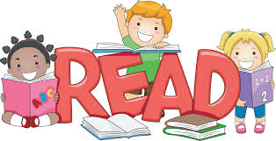
Grade Two Reading News
In Room 106

September 8, 2015
Wow!! Our first week in grade two has come and gone in a flurry of activity. All students are working hard and settling into the classroom. We will continue to spend time going over routines and expectations all this month. Last week the class came up with a T chart describing What Happens in a Learning Classroom and we now how this displayed in our classroom. There are three main headings: Follow Directions; Be Respectful; and Try Your Best. Under each of these headings we have detailed descriptors of what this looks like. Feel free to come and check this out so you know what we are hoping to achieve.
Both Mrs. Tanton and I are looking forward to seeing everyone at the School Barbeque Tuesday September 15 from 5-7.

Home Reading Program: Today is our official start to the home reading program that runs throughout the year. Tonight you will hopefully notice that your child has brought home a book to read. The book should be in their agenda Ziploc bag in their backpack. One of the most important things you can do as a parent to help your child achieve in school is to set up a regular schedule of quiet, relaxing reading. 10 – 15 minutes of consistent nightly reading can go a long way to literacy success!
Grade two students are bringing home books at their reading level. If you find that the reading is too easy or too difficult please put a note in the agenda and we will adjust the level accordingly.
Attached in the back of each child’s agenda is a Reading log sheet. Please record the title of the book and approximately how many minutes were spent reading. Your child can then give some feedback on how they enjoyed the book by drawing the appropriate face.
If you have any questions, please feel free to contact me at the school
Sincerely,
Mrs. McNabb

